**Natural Language Processing**

  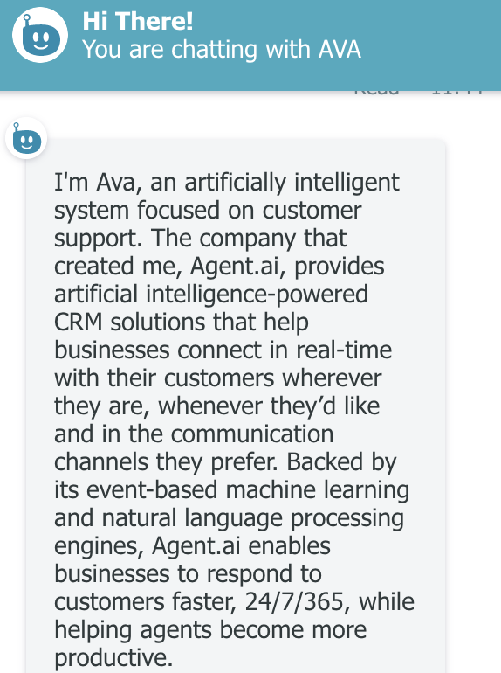

**Natural Language Processing**

Natural Language Processing or NLP for short, is a field of study focused on the interactions between human language and computers. It sits at the intersection of computer science, artificial intelligence, and computational linguistics. Kind of heavy…. right!!!

**Let’s break it down and simplify each part:**

* NLP is a field of study in com­puter science, that helps computers un­der­stand and ma­nip­u­la­te of hu­man lan­guage. It’s not exactly the word play that human’s practice during an argument, but, let’s say it could be used to decipher what was really meant.
* Think of it as a software that helps computers understand what we say just by listening to us or reading what we write even we write it like a general conversation and not as a set of instructions in a computer program. Ex. chat bots. They make use of this technology to understand what we are saying.
* When we ask Alexa to tell us a joke. When we tell Siri, she looks beautiful. When we ask Google, when was Barack Obama born. All of this is broken down from human language to a computer understandable 0 and 1 using natural language processing.
* NLP is a way for computers to analyze, understand, and derive meaning from human language in a smart and useful way. By utilizing NLP, computer programmers can look at knowledge in a way that allows them to perform tasks like text summarization, translation, entity identification, relationship extraction, sentiment analysis, etc.

**What can I use natural language processing for?**

* **Automatically generate keyword tags** from content using [topi](https://algorithmia.com/algorithms/nlp/AutoTag?utm_source=blog&utm_medium=post&utm_campaign=nlp)c , which leverages a technique that discovers topics contained within a body of text.
* **Identify entities**, such as a person, place, or organization using [Named Entity Recognition](https://algorithmia.com/algorithms/StanfordNLP/NamedEntityRecognition?utm_source=blog&utm_medium=post&utm_campaign=nlp).
* Use [Sentiment Analysis](https://algorithmia.com/algorithms/nlp/SentimentAnalysis?utm_source=blog&utm_medium=post&utm_campaign=nlp) to **identify the sentiment of a string of text**, from very negative to neutral to very positive.

**Real-world Use cases of natural language processing**

1. Social Media analysis: Brands track conversations online to understand what customers are saying and glean insight into user behavior.
2. Tracking sentiment: The tone of a written message (tweet, Facebook update, etc.) — and tag that text as positive, negative or neutral.
3. Track trending topics and popular hashtags: Hashtags and topics are two different ways of grouping and participating in conversations. E.g. Facebook, Twitter
4. Publishers use NLP to improve the quality of their online communities by leveraging technology to “auto-filter” the offensive comments on news sites to save moderators from what can be an exhausting process.

**Other Use cases:**

1. Banks can use it to track user interest and increase transactions.
2. Media houses can use it to hog more money with dynamic pricing for ad slots.

**Sources:**

<https://medium.com/@jha0109/natural-language-processing-nlp-for-dummies-8c318a127b86>

<https://www.cultofmac.com/447783/today-in-apple-history-siri-makes-its-public-debut-on-iphone-4s/>